32. Develop a system using UML for Jewel Loan Management System. The admin should add new customers and view the customers' records. The admin should check the defaulters. The customer can see his/her account detail and apply for a new loan by providing the required ornaments. The admin should verify the purity of the ornaments submitted and approve the loan after verifying the payback potential of the customer.

**CLASS DIAGRAM :**

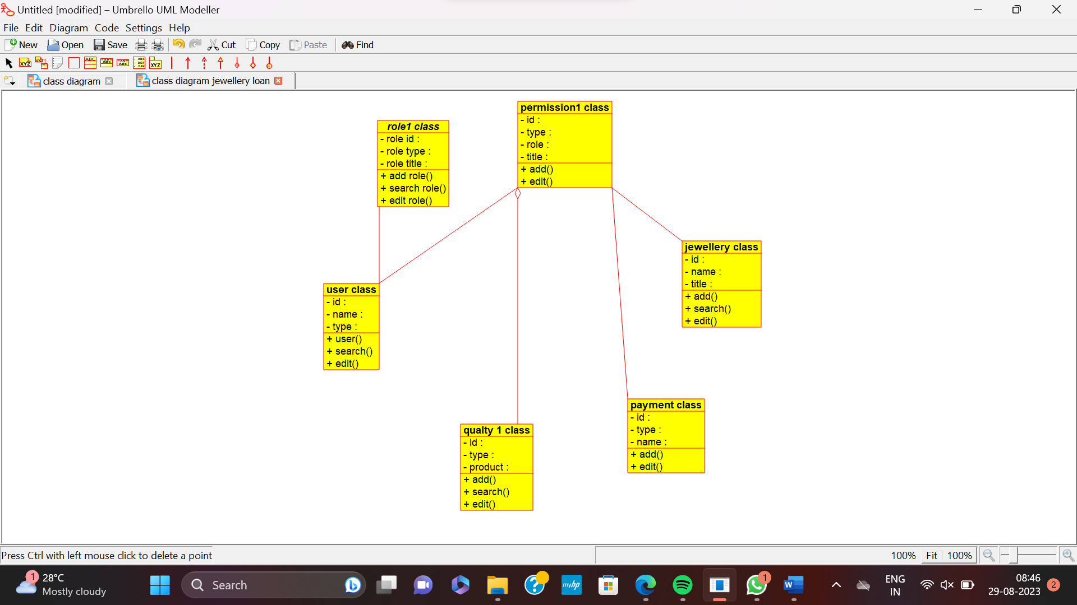

**USE CASE :**

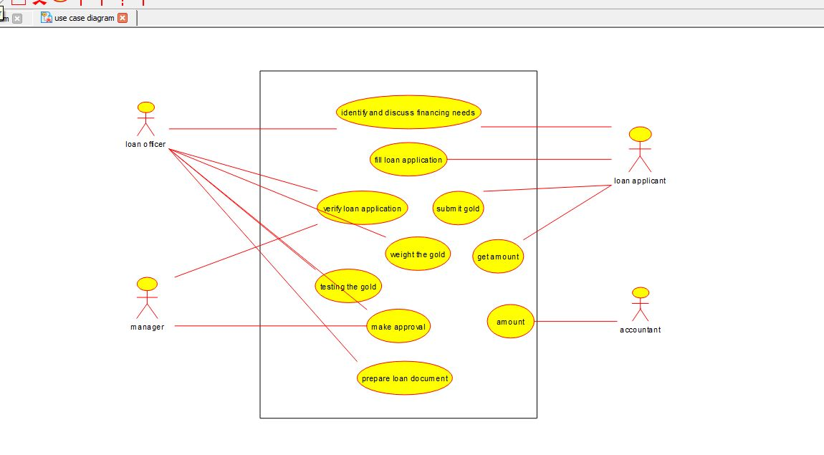

**SEQUENCE :**

